
Specification Sheet

C.S.B. INTERNATIONAL PRODUCTS INC.

1 ½" G/J Sink Trap, X-Large Tube Sweat Elbow, W/ CO., R/W, D/F B/N

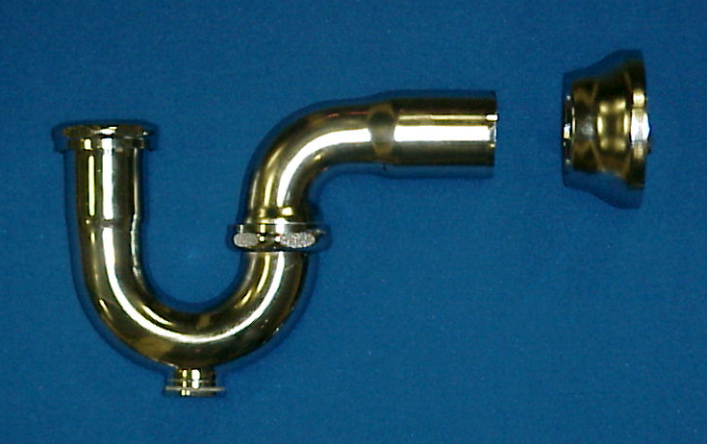

Part Number | Size | Finish | Material
1234XBDCP | 1 ½" 17 GA. | CP | Brass

Tel: (860) 263-3635, Fax: (860) 229-4328

E-mail: sales@csbint.biz

41 Hammer Hill Road,
Rocky Hill, CT 06067

